**virtual machine and to load zip file to unzip file**

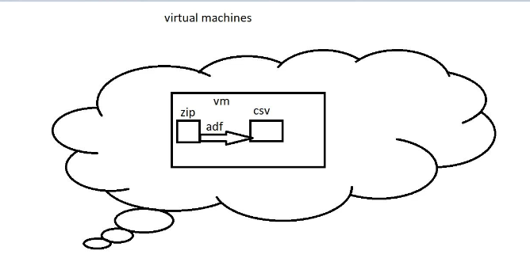

Create virtual machine:

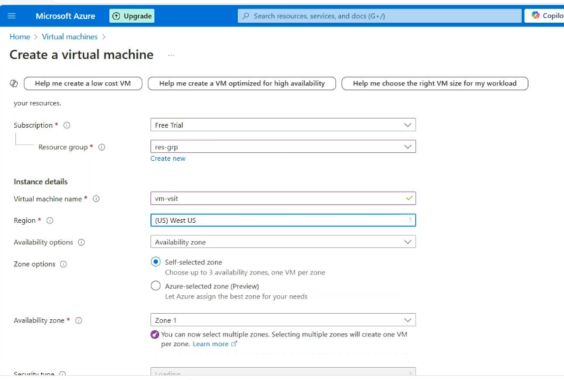

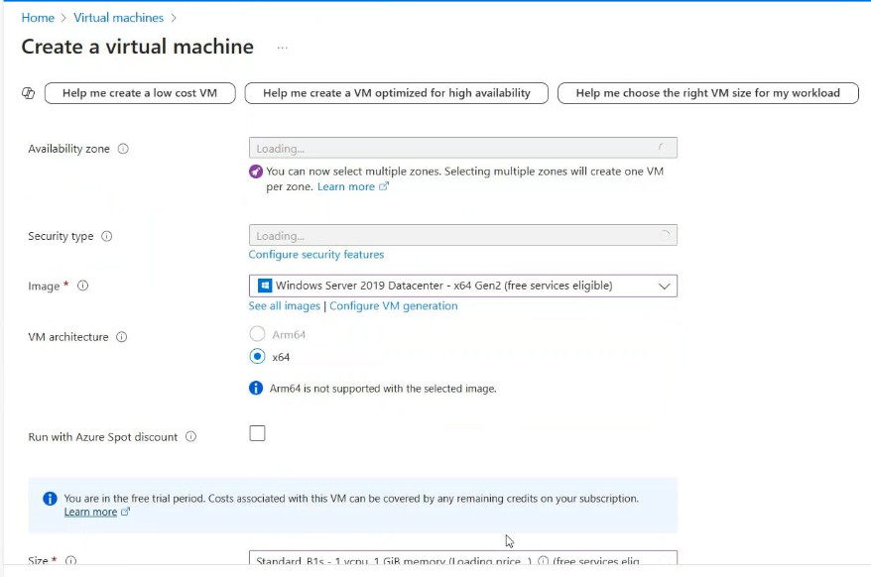

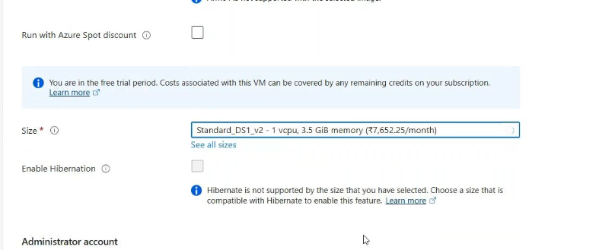

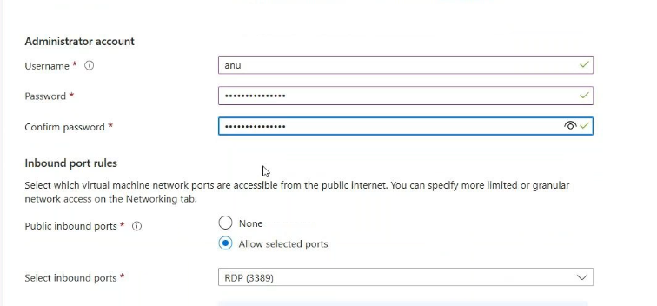

Review and create

Then create ADF:

Then go to the virtual machine🡪copy the public ip🡪connect with remote desktop connection

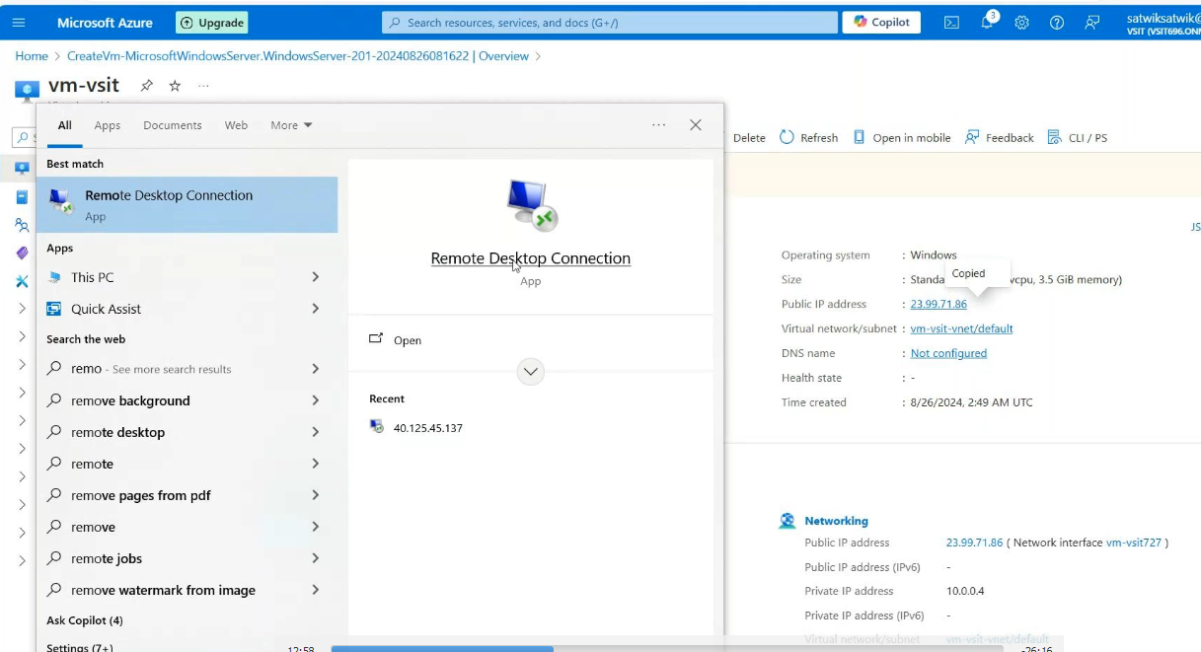

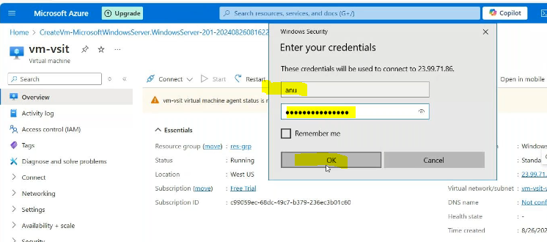

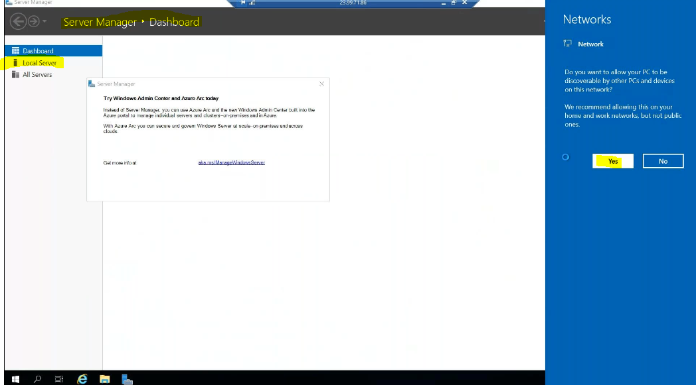

Off the security configuration

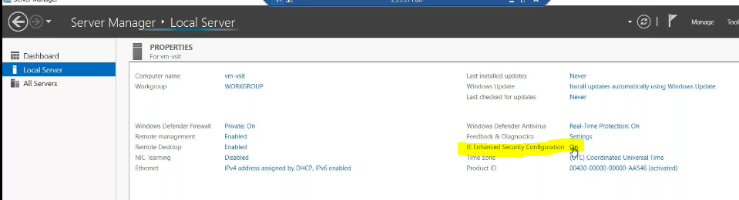

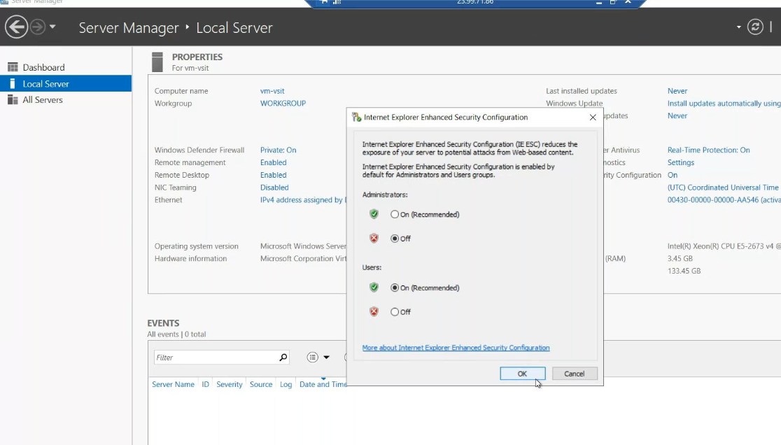

Open the micro soft edge:

It is as it windows server;

Then go to adf 🡪create self hosted ir🡪

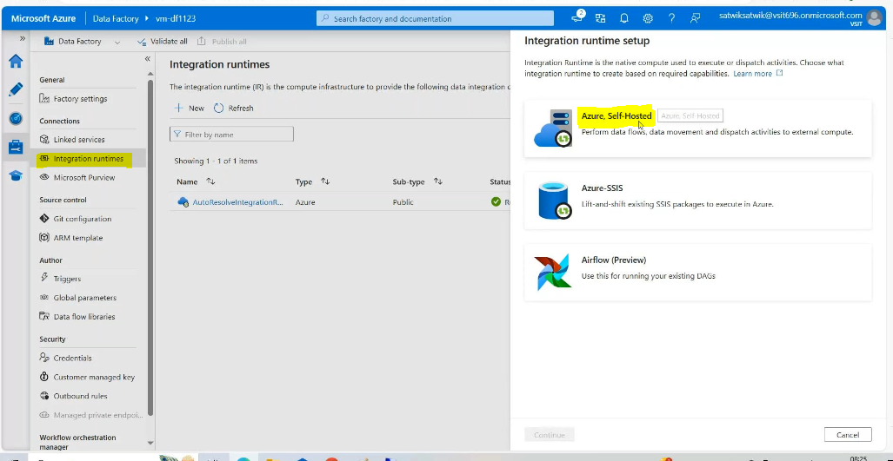

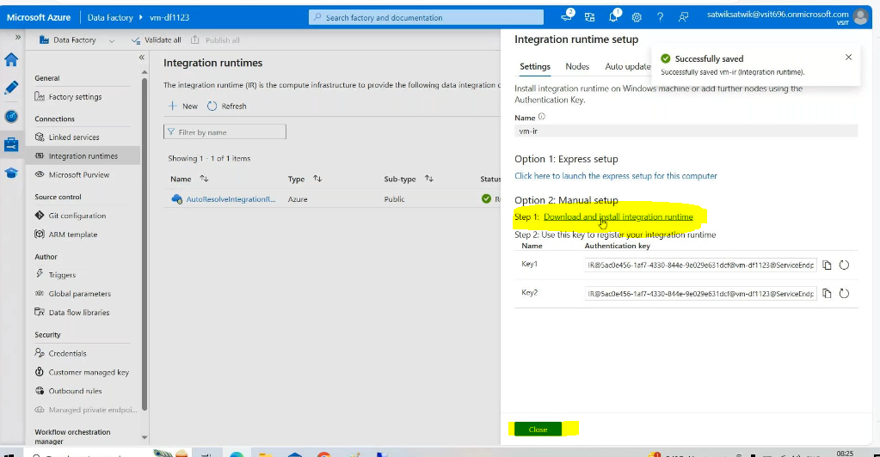

Copy the link local system :

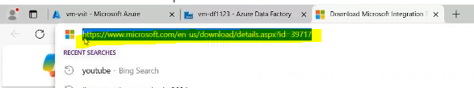

Past in virtual machine:

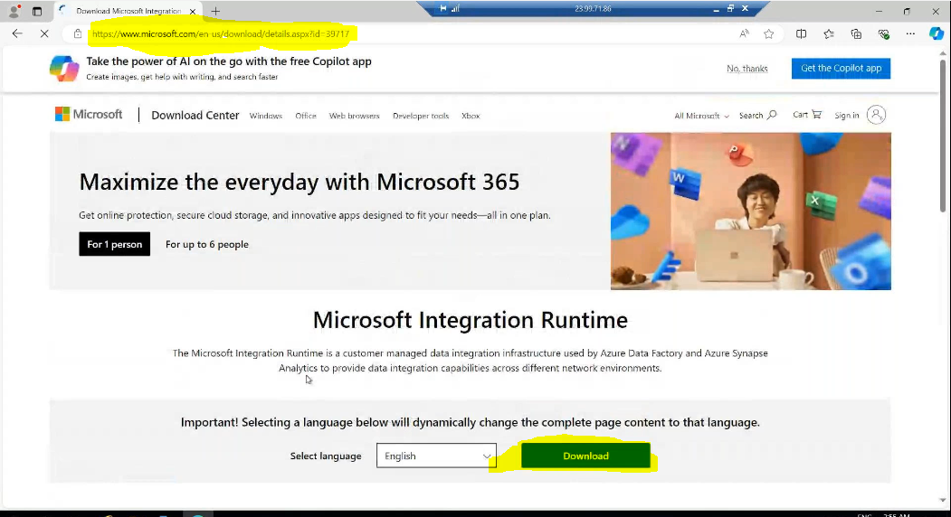

Then login the azure portal in virtual machine:

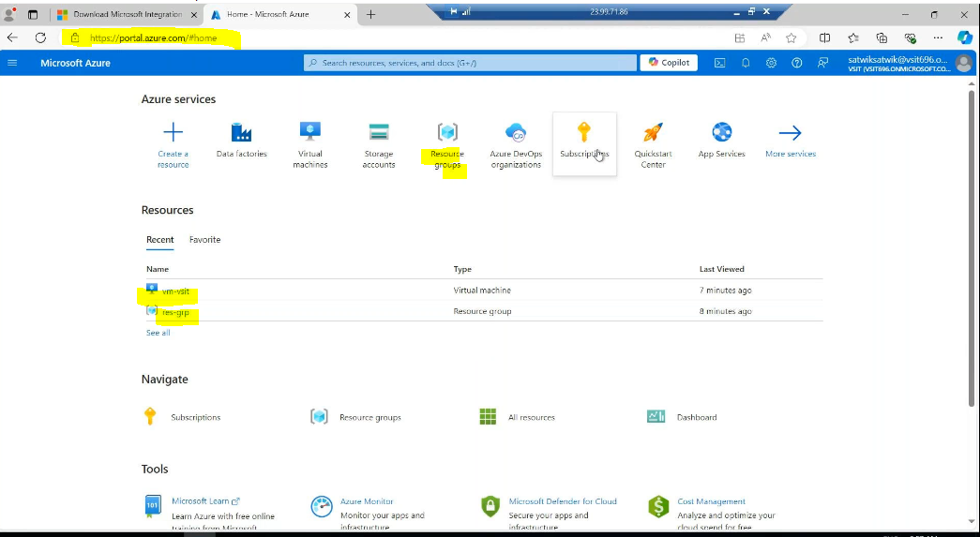

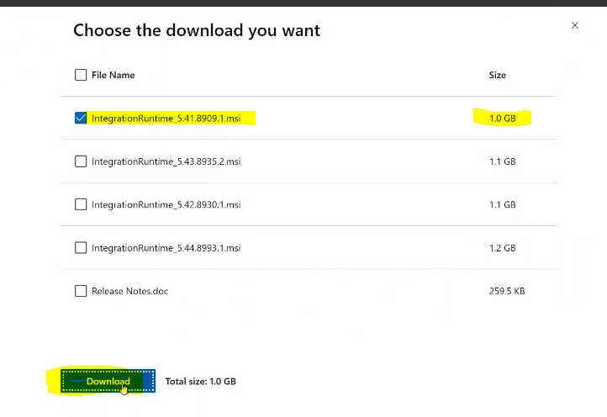

Open the file



Run the file :

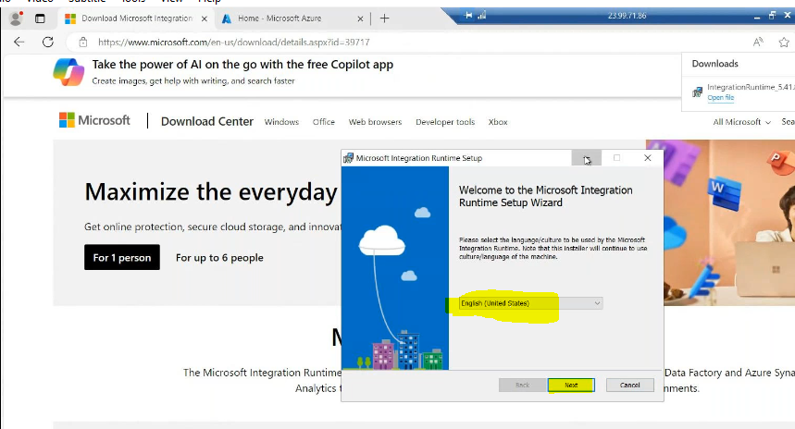

Then create a blob storage in virtual machine:

Upload the any zip file in blob storage in our local machine it reflect in the virtual machine also

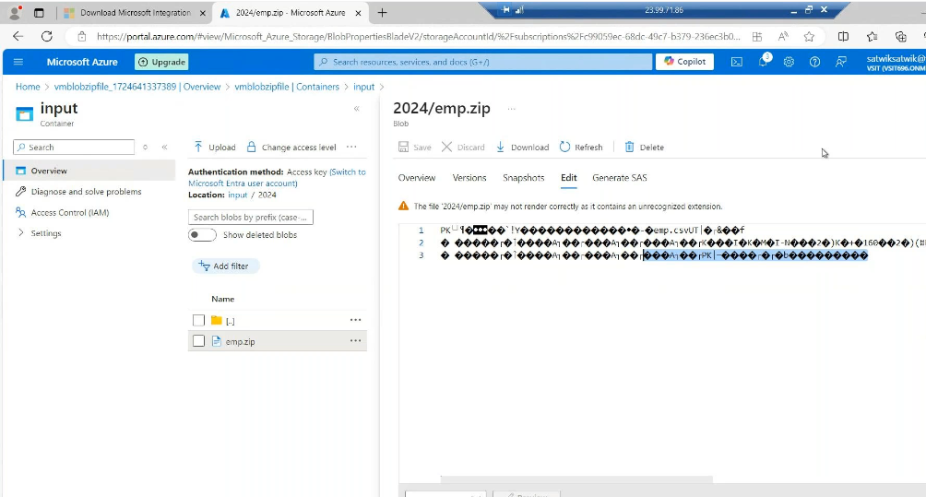

Then create output container in blob storage:

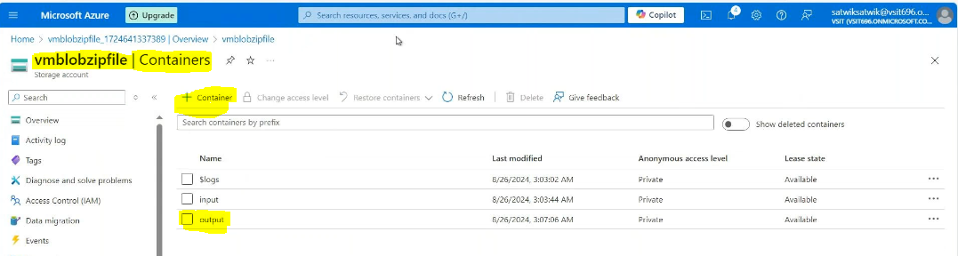

I want to convert the zip file in (input container) into csv files in output container.

Create or open the ADF IN virtual machine open the self hosted copy the key and paste in

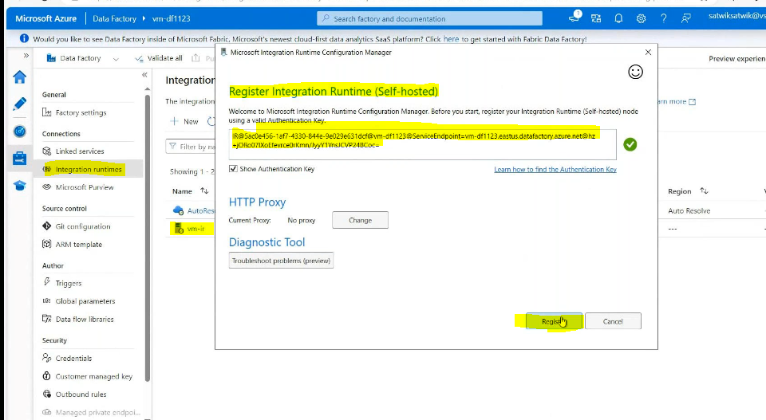

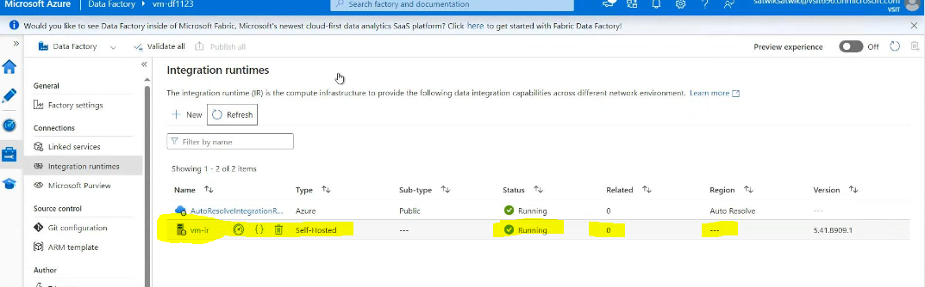

Create linked service for blob:

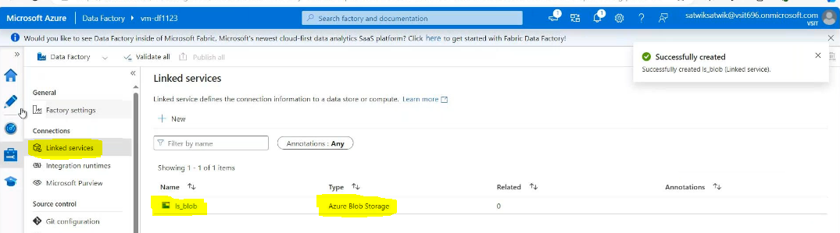\

Create dataset for source side:

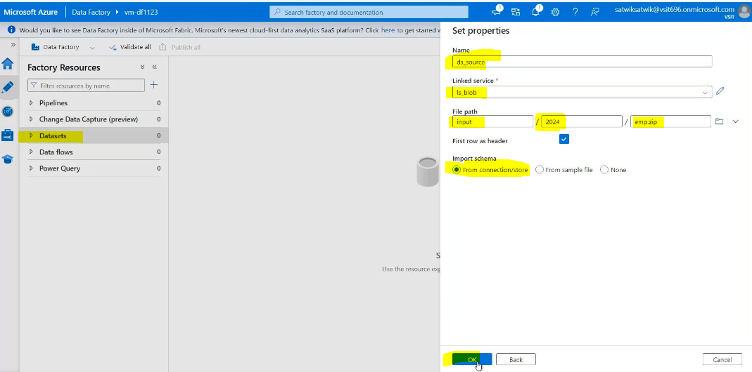

Create dataset for sink side:

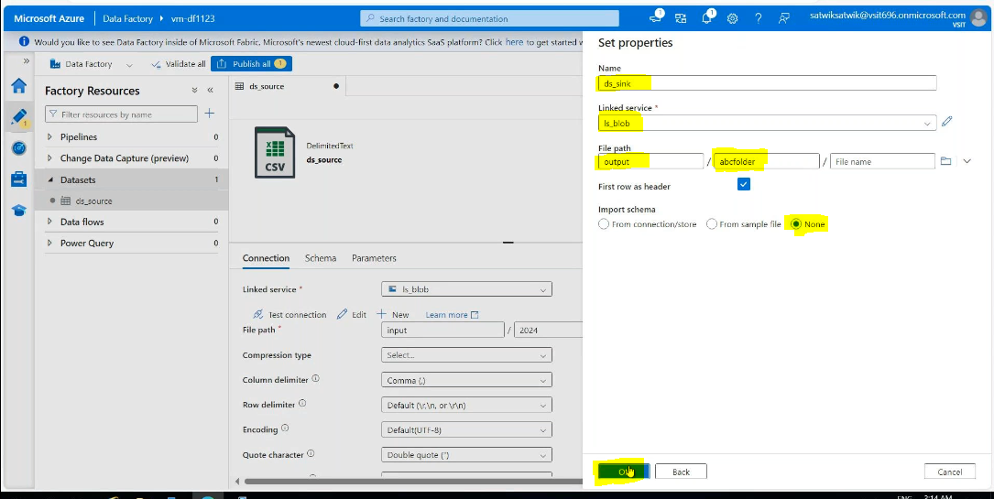

Create pipeline 🡪Copy data activity🡪source side

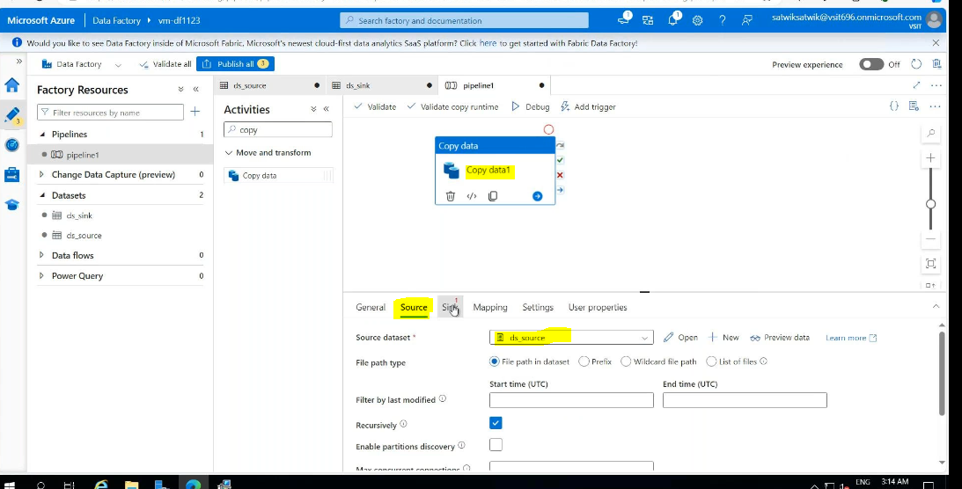

Then open the source side data set: in compression type zipdatatype file

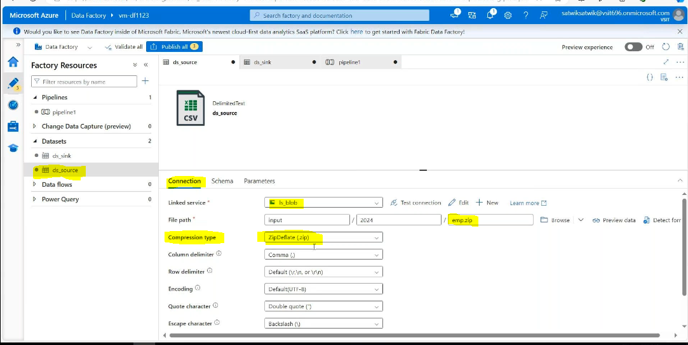

Sink side:

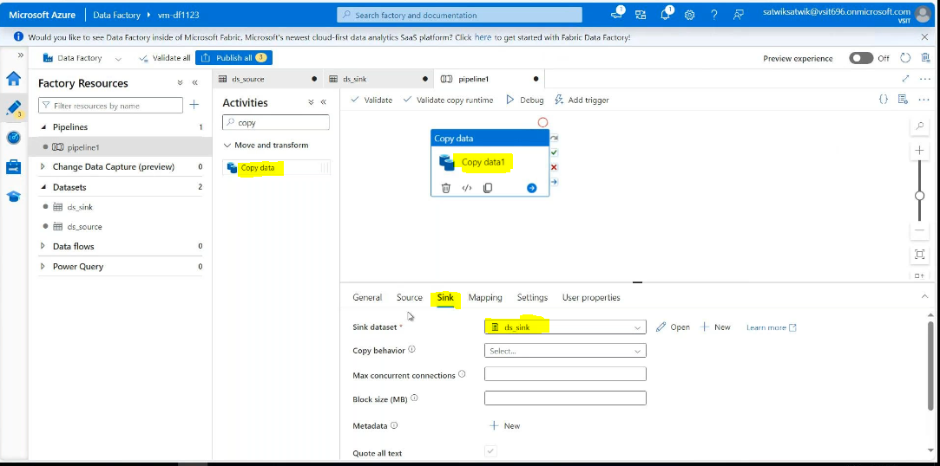

In file extension type is .csv

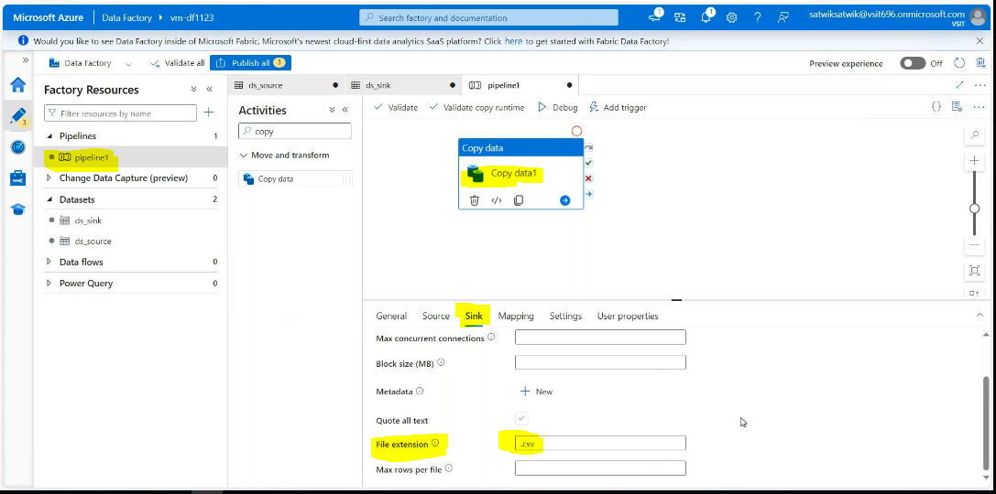

Validate & debug

Result:

